**American International University-Bangladesh**

**Faculty of Engineering**

**Midterm Assessment (Spring 2020-2021)**

**Computer Aided Design and Drafting**

**Marks: 40**

***\*\*\*Each question contains 2 marks.***

1. If you want to make a fillet in an object which of the following you should define?

a. Distance

* 1. **Radius**
  2. Diameter
  3. a & b both

1. To draw the same sized object in circular way which of the following array option is used?
   1. Rectangular array
   2. Circular array
   3. **Polar array**
   4. None of these above
2. What is the sequence of the object-picture plane-observer in 4th angle projection?
   1. **Object-picture plane-observer**
   2. Observer-picture plane-object
   3. Picture plane-object-observer
   4. Picture plane- observer- object
3. What do we call this question marked line?

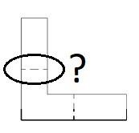

a. Dashed line b. Hidden line c. cutting plane line **d. a & b both**

1. Consider “X” representing the dimension of this line in the following figure. What is the value of “x”?

a. 4.5 b. 3.5 **c. 4** d. 5

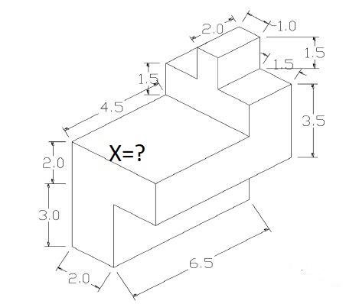

1. Which of the following angles are not the angles of isometric projection?
2. **120 degree**
3. 30 degree
4. 60 degree
5. a & b both
6. Isometric views are three dimensional. **True**
7. The difference of first and third angle projections is the relative positions of
   1. **observer, object and the picture plane**
   2. object and the picture plane.
   3. Observer and the object
   4. observer and the picture plane
8. How can you classify the projection?
   1. Depending on the shape of the object
   2. **Depending on the rays of the sight**
   3. Depending on the position of the object
   4. Depending on the position of the observer
9. How many categories of the scale we have in AutoCAD drawing?
   1. 4
   2. **3**
   3. 5
   4. 2
10. To draw the hidden edge of an object, dashed line is used. **True**
11. In an isometric view, right-hand side view is usually at ………… degree angle with the horizontal position.
    1. 60
    2. 90
    3. **30**
    4. 120
12. The lengths are same for which options of orthographic views: 1. Front 2. Right 3. Left

4. Top

* 1. 1&2
  2. 3&4
  3. **4&1**
  4. 1&3

1. The heights are same for which options of orthographic views: 1. Front 2. Right 3. Left

4. Top

* 1. 1&2
  2. 3&4
  3. **1,2&3**
  4. 1&3

1. To move an object at any point which option should be chosen?
   1. Polar
   2. Grid
   3. Ortho
   4. **None**
2. Projection of an inclined surface is always smaller than the length of that (inclined) surface. **True**

1. Which line is thickest?
   1. **Object line**
   2. Extension line
   3. Dashed line
   4. Center line
2. Orthographic views are two-dimensional views. **True**
3. Which option is used to draw AC signal in designing a circuit?
   1. Polygon
   2. **Spline**
   3. 3-point arc
   4. Fillet
4. Which option is used to fill an object with color?
   1. Extrude
   2. **Hatch**
   3. Gradient
   4. Chamfer